PREDICTING STUDENT EXAM PERFORMANCE
A DATA SCIENCE AND MACHINE LEARNING CAPSTONE STUDY

Project Report Submitted in fulfillment of the Requirements for the Internship of the Summer Training Program by IDRA

Student Name: Aimin Jayamon
Class: S3 AD
Roll No.: 4
Institute: UNIVERSITY COLLEGE OF ENGINEERING THODUPUZHA
Program: Data Science and AI
Enrollment No: IDRA-2026-544641
Platform: India Data Research Academy

Through the platform:

India Data Research Academy

UNDER THE SUPERVISION OF
Dr. Shaheena Salam

DECLARATION
I hereby declare that this capstone project report presents my own analysis and interpretation of the Student Performance Factors dataset. The data preparation, exploratory analysis, statistical analysis, machine learning workflow, evaluation, and report preparation were completed as part of the IDRA Data Science and AI training program. External resources, where used, are acknowledged appropriately

ACKNOWLEDGEMENT
I sincerely thank the India Data Research Academy and the IDRA training program for providing the learning environment, project guidance, dataset, and capstone framework. I also thank the trainers and supervisors for their support throughout the training. Finally, I acknowledge the dataset and report template supplied through the LMS, which provided the foundation for this study.

ABSTRACT

This study investigates factors associated with student examination performance and develops a machine learning model for predicting Exam_Score. The supplied Student Performance Factors dataset contains 6,607 records and 20 variables covering study behaviour, attendance, sleep, previous scores, tutoring, family and school conditions, motivation, peer influence, and other student characteristics. Data cleaning identified 235 missing cells, no duplicate records, and one invalid exam-score value above the valid 0–100 range. Missing categorical values were imputed using the mode and the invalid record was removed. Exploratory analysis showed that attendance and hours studied were among the strongest numerical relationships with exam performance, while parental involvement, access to resources, motivation, and peer influence also showed meaningful group differences. A Study_Attendance_Index was engineered to represent combined study effort and attendance. Linear Regression, Random Forest, and Gradient Boosting models were compared using an 80/20 train-test split. Linear Regression achieved the strongest test performance, with MAE of 0.418, RMSE of 1.522, and R² of 0.825. The results indicate that a relatively simple regression model can capture a substantial proportion of variation in exam scores from the available student factors. The study concludes with practical recommendations focused on attendance, study habits, academic support, and targeted student interventions.
Keywords: student performance; exploratory data analysis; regression; machine learning; educational analytics

TABLE OF CONTENTS
1. Introduction
2. Problem Statement and Motivation
3. Objectives
4. Research Questions
5. Dataset Description and Data Understanding
6. Data Cleaning
7. Data Preprocessing
8. Exploratory Data Analysis
9. Statistical Analysis
10. Feature Engineering
11. Model Development
12. Model Evaluation
13. Results and Findings
14. Discussion
15. Limitations
16. Conclusion
17. Recommendations and Future Work
18. References
Appendix A. Code
Appendix B. Additional Figures and Tables

1. INTRODUCTION

1.1 Background
Student academic performance is influenced by a combination of learning behaviour, attendance, prior achievement, support systems, motivation, and environmental conditions. Educational analytics can help identify patterns in these factors and provide evidence for targeted academic support. This project applies a complete data science workflow to a student performance dataset supplied for the capstone project.

1.2 Context of the Problem
The main stakeholders are students, teachers, academic coordinators, and institutions. A reliable predictive model can help identify patterns associated with stronger or weaker expected examination performance. The analysis is intended as decision support rather than as a replacement for teacher judgement or individual student assessment.

1.3 Scope of the Study
The study covers data quality assessment, cleaning, preprocessing, exploratory and statistical analysis, feature engineering, regression modelling, evaluation, interpretation, and recommendations. It does not establish causal relationships, diagnose individual students, or claim that the model will generalize unchanged to every school or population.

2. PROBLEM STATEMENT AND MOTIVATION
The central problem is: How accurately can student examination scores be predicted from behavioural, academic, family, school, and support-related factors available in the dataset? Solving this problem can help demonstrate how educational data can be transformed into actionable insights and predictive evidence.

3. OBJECTIVES
- Understand the structure, quality, and important characteristics of the Student Performance Factors dataset.
- Identify major patterns and relationships between student characteristics and Exam_Score.
- Clean and preprocess the dataset using reproducible data science techniques.
- Engineer a meaningful combined feature representing study effort and attendance.
- Develop and compare regression models for predicting Exam_Score.
- Evaluate the best model and translate the findings into practical recommendations.

4. RESEARCH QUESTIONS
- What are the main data-quality issues in the supplied dataset?
- Which numerical variables have the strongest relationships with Exam_Score?
- How does average exam performance differ across important categorical groups?
- How accurately can regression models predict Exam_Score?
- Does the selected model show evidence of overfitting or underfitting?

5. DATASET DESCRIPTION AND DATA UNDERSTANDING

5.1 Data Source
The dataset used in this project is the Student Performance Factors CSV supplied with the capstone materials. The IDRA report template specifies that the LMS-provided dataset should be identified as the project data source.

5.2 Dataset Size and Structure
The raw dataset contains 6,607 rows and 20 columns. After removing one invalid Exam_Score record, the analytical dataset contains 6,606 rows. The target variable is Exam_Score because the project objective is to predict student examination performance.
Measure | Value
Raw rows | 6,607
Raw columns | 20
Analytical rows | 6,606
Numerical variables | 8
Categorical variables | 13
Target | Exam_Score
Duplicate rows in raw data | 0
Missing cells in raw data | 235

5.3 Data Dictionary
Variable | Meaning | Type | Role
Hours_Studied | Weekly/recorded study hours | Integer | Feature
Attendance | Attendance percentage | Integer | Feature
Parental_Involvement | Level of parental involvement | Categorical | Feature
Access_to_Resources | Level of educational resource access | Categorical | Feature
Extracurricular_Activities | Participation in extracurricular activities | Categorical | Feature
Sleep_Hours | Average sleep hours | Integer | Feature
Previous_Scores | Previous academic score | Integer | Feature
Motivation_Level | Student motivation level | Categorical | Feature
Internet_Access | Internet access availability | Categorical | Feature
Tutoring_Sessions | Number of tutoring sessions | Integer | Feature
Family_Income | Family income category | Categorical | Feature
Teacher_Quality | Teacher quality category | Categorical | Feature
School_Type | Public/private school type | Categorical | Feature
Peer_Influence | Peer influence category | Categorical | Feature
Physical_Activity | Physical activity level | Integer | Feature
Learning_Disabilities | Learning disability indicator | Categorical | Feature
Parental_Education_Level | Parent education category | Categorical | Feature
Distance_from_Home | Distance category | Categorical | Feature
Gender | Student gender | Categorical | Feature
Exam_Score | Examination score | Integer | Target

6. DATA CLEANING

6.1 Missing Values
The raw dataset contains 235 missing cells. Missing values occur in Teacher_Quality (78), Parental_Education_Level (90), and Distance_from_Home (67). Because these are categorical variables, the mode of each variable was used for imputation. This preserves all available observations while applying a simple reproducible treatment.
Column | Missing Count | Treatment
Teacher_Quality | 78 | Mode imputation
Parental_Education_Level | 90 | Mode imputation
Distance_from_Home | 67 | Mode imputation

6.2 Duplicate Records
No duplicate records were found in the raw dataset (0 duplicates). Therefore, no rows were removed for duplication.

6.3 Data Types and Inconsistent Values
The numerical variables were already represented as numeric data types and the qualitative variables were represented as object/string categories. Category labels were inspected and did not require manual recoding. Exam_Score contained one value of 101, which is outside the valid 0–100 range and was treated as an invalid observation and removed.

6.4 Outlier Handling
IQR-based screening was performed on the main numerical variables. Potential outliers were detected in Hours_Studied (43) and Tutoring_Sessions (429). These observations were retained because they can represent genuine differences in student behaviour and are not automatically invalid. The single Exam_Score value of 101 was handled separately as an invalid value because exam scores are bounded by 100.

6.5 Before vs After Cleaning
Quality Measure | Before | After | Decision
Rows | 6,607 | 6,606 | Removed 1 invalid exam score
Columns | 20 | 21 | No structural columns removed
Missing cells | 235 | 0 | Categorical missing values imputed
Duplicate rows | 0 | 0 | No duplicates found
Invalid Exam_Score > 100 | 1 | 0 | Removed invalid record

7. DATA PREPROCESSING

7.1 Categorical Encoding
Categorical variables were transformed using one-hot encoding. This approach represents each category as a separate binary indicator and avoids imposing an artificial numerical order on nominal categories.

7.2 Feature Scaling and Transformation
Numerical features were standardized within the preprocessing pipeline. Median imputation was included as a safeguard, and scaling was fitted only on the training data through the pipeline to reduce the risk of data leakage.

7.3 Train-Test Split
The cleaned data was split into 80% training data and 20% test data using random_state=42. The training set was used to fit preprocessing and models, while the test set was kept unseen until evaluation.

7.4 Final Feature Set
The model uses the original explanatory variables except Exam_Score, plus the engineered Study_Attendance_Index. The target variable is Exam_Score.

8. EXPLORATORY DATA ANALYSIS

8.1 Univariate Analysis
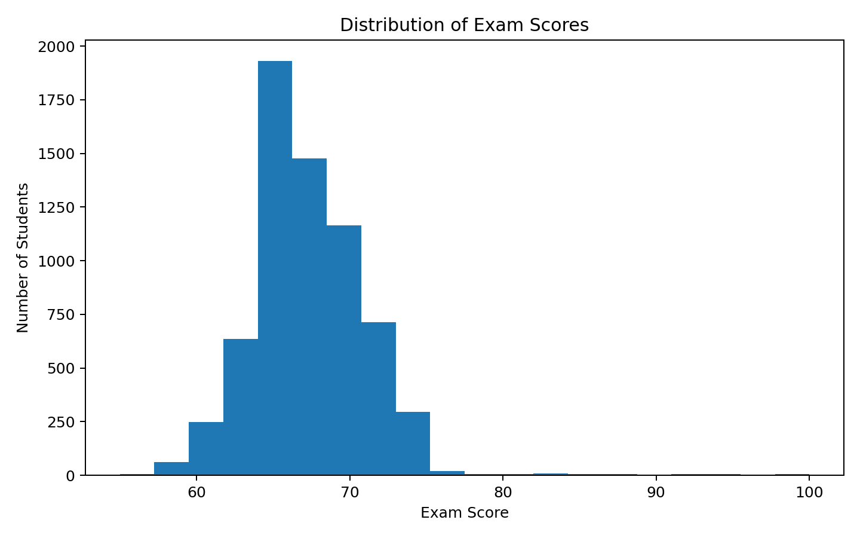
Figure 1. Distribution of Exam_Score
The cleaned Exam_Score values range from 55 to 100, with a mean of 67.23. The distribution is concentrated around the mid-to-high 60s, with relatively limited spread. The invalid value of 101 was removed before analysis.

8.2 Categorical Analysis
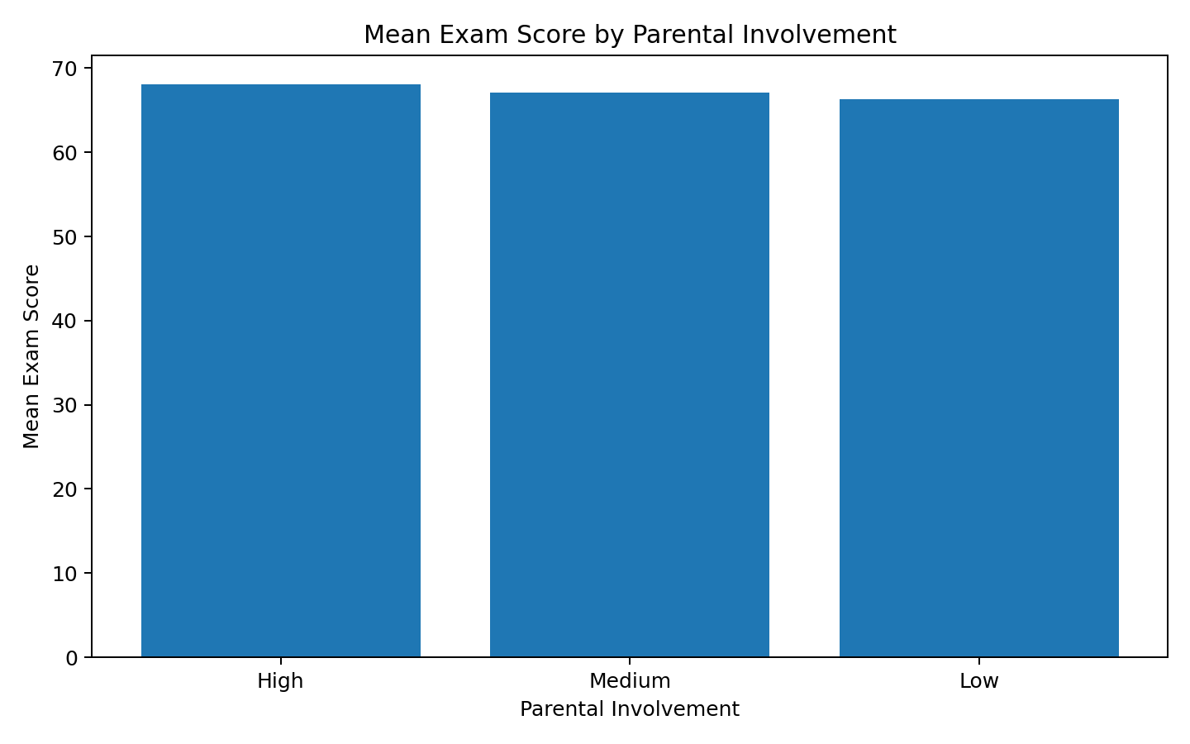
Figure 2. Mean Exam Score by Parental Involvement
Students in the High parental-involvement group have the highest average exam score (68.09), followed by Medium (67.10) and Low (66.33). This is an observed group difference and should not be interpreted as proof of causation.

8.3 Bivariate / Relationship Analysis
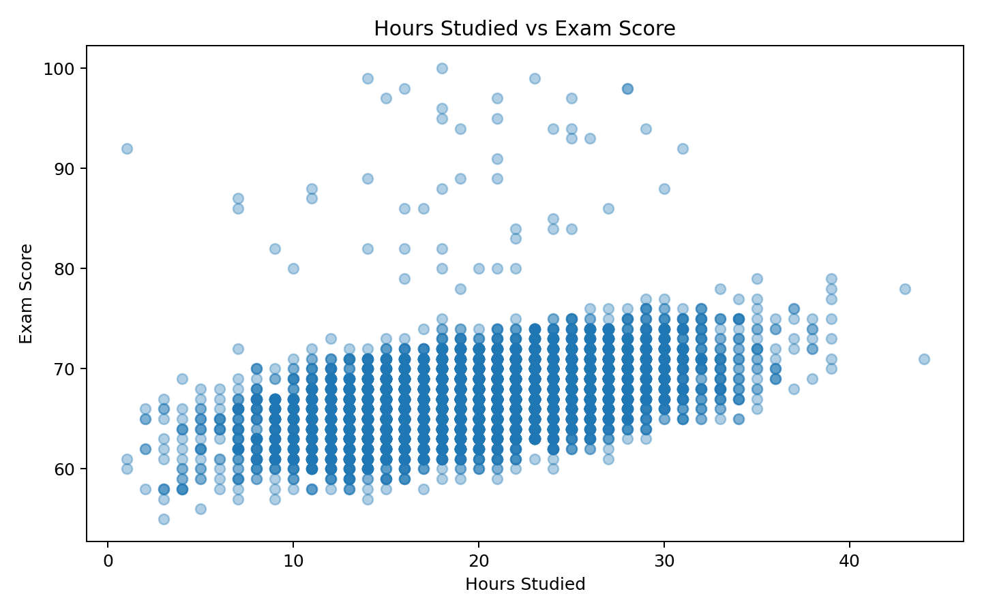
Figure 3. Relationship Between Hours Studied and Exam Score
Hours_Studied has a positive correlation with Exam_Score of 0.447. The scatter plot shows that higher study hours generally coincide with higher scores, although individual variation remains substantial.

8.4 Correlation Analysis
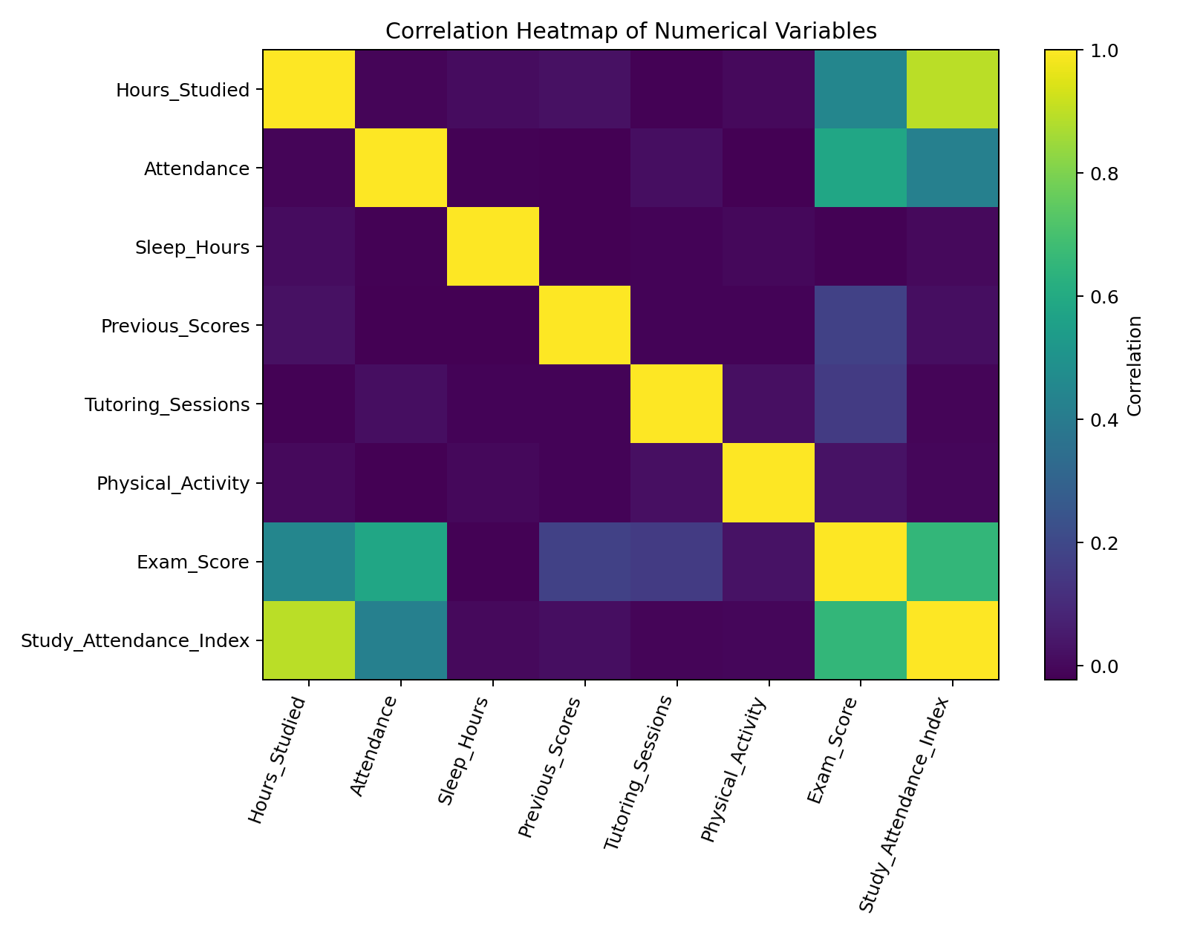
Figure 4. Correlation Heatmap of Numerical Variables
Attendance has a correlation of 0.582 with Exam_Score, while Hours_Studied has a correlation of 0.447. Previous_Scores (0.174) and Tutoring_Sessions (0.154) show smaller positive relationships. Sleep_Hours has a near-zero relationship (-0.016) in this dataset.

8.5 Other Figures
Additional analysis compared motivation, access to resources, peer influence, family income, teacher quality, and other categorical factors. The observed mean-score differences were generally modest compared with the stronger numerical relationships for attendance and study behaviour.

9. STATISTICAL ANALYSIS
Variable | Mean | Median | Std Dev | Min | Max
Hours_Studied | 19.97 | 20.00 | 5.99 | 1 | 44
Attendance | 79.97 | 80.00 | 11.55 | 60 | 100
Sleep_Hours | 7.03 | 7.00 | 1.47 | 4 | 10
Previous_Scores | 75.07 | 75.00 | 14.40 | 50 | 100
Tutoring_Sessions | 1.49 | 1.00 | 1.23 | 0 | 8
Physical_Activity | 2.97 | 3.00 | 1.03 | 0 | 6
Exam_Score | 67.23 | 67.00 | 3.87 | 55 | 100

Exam_Score has a mean of 67.23 and standard deviation of 3.87, indicating a relatively compact score distribution. Attendance averages 79.97% and Hours_Studied averages 19.97. The strongest simple numerical association with Exam_Score is the engineered Study_Attendance_Index (r=0.653), followed by Attendance and Hours_Studied.

10. FEATURE ENGINEERING
Engineered Feature | Formula / Logic | Purpose
Study_Attendance_Index | Hours_Studied × Attendance / 100 | Combines study effort and attendance into one continuous indicator of academic engagement.

The engineered feature was created after data cleaning and before model training. It is intended to capture the combined effect of two behaviour-related variables that individually show positive relationships with exam performance.

11. MODEL DEVELOPMENT

11.1 Problem Formulation
This is a supervised regression problem. The target variable is Exam_Score, a numerical examination outcome. The input variables include study behaviour, attendance, prior performance, student support factors, school context, and the engineered Study_Attendance_Index.

11.2 Model Selection
Three regression algorithms were compared: Linear Regression, Random Forest Regressor, and Gradient Boosting Regressor. Linear Regression provides a transparent baseline, while the tree-based models can capture nonlinear relationships and interactions.

11.3 Training the Model
All preprocessing operations were placed inside a scikit-learn Pipeline and ColumnTransformer. The models were trained on the 80% training split and evaluated on the untouched 20% test split.

12. MODEL EVALUATION

12.1 Regression Evaluation
Model | Train MAE | Test MAE | RMSE | R²
Linear Regression | 0.506 | 0.418 | 1.522 | 0.825
Random Forest | 0.524 | 0.989 | 1.870 | 0.735
Gradient Boosting | 0.726 | 0.740 | 1.710 | 0.779

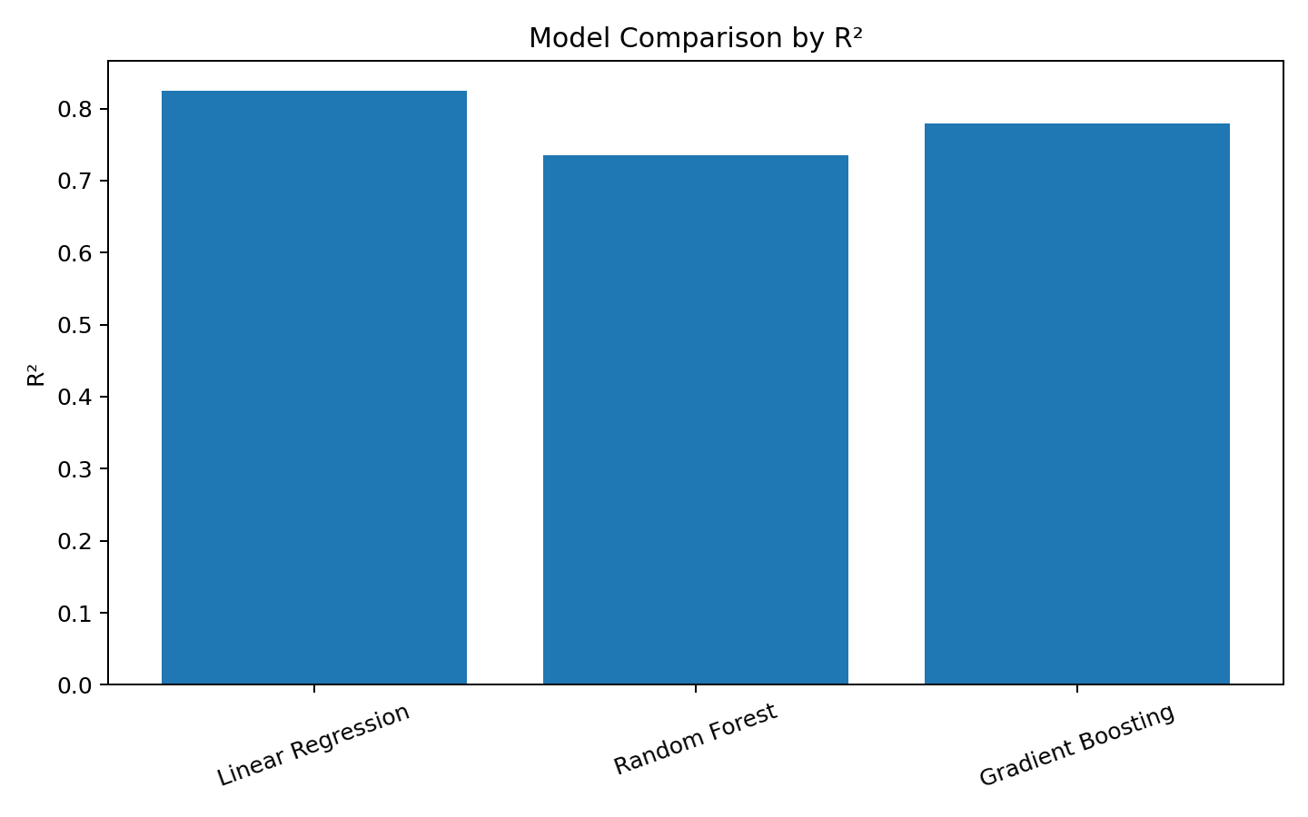
Figure 5. Model Comparison by R²
Linear Regression achieved the best test R² (0.825) and the lowest test MAE (0.418) among the tested models. An MAE of about 0.42 means the model's predictions differ from the actual test scores by roughly that many score points on average. The RMSE of 1.522 also indicates relatively small prediction errors on this dataset.

12.2 Classification Evaluation
A classification version was not used as the primary capstone model because the supplied Exam_Score values are tightly concentrated above common pass thresholds. Regression retains the full numerical information in the target and is therefore more informative for this dataset.

12.3 Overfitting and Underfitting
For the selected Linear Regression, training MAE is 0.506 and test MAE is 0.418. The close values suggest limited evidence of severe overfitting. The test R² remains high relative to the alternative models, indicating that the model generalizes reasonably well to the held-out sample.

13. RESULTS AND FINDINGS
1. Attendance is strongly associated with exam performance (r=0.582), making consistent attendance an important predictive factor.
2. Hours_Studied has a moderate positive association with Exam_Score (r=0.447); students reporting more study time tend to have higher scores.
3. Parental involvement shows a clear group gradient: High involvement averages 68.09, compared with 66.33 for Low involvement.
4. Access to resources and motivation also show positive group differences, with High Access_to_Resources averaging 68.09 and High Motivation_Level averaging 67.70.
5. Linear Regression is the strongest tested model, achieving test MAE=0.418, RMSE=1.522, and R²=0.825.

14. DISCUSSION
The analysis indicates that student performance in this dataset is most closely connected to observable academic engagement variables, especially attendance and study effort. The engineered Study_Attendance_Index strengthens this interpretation by combining two related behaviours. Previous achievement and tutoring also contribute positive information, although their simple correlations are weaker. Categorical variables such as parental involvement, access to resources, motivation, and peer influence show smaller but consistent differences in group means. These patterns support the value of combining behavioural, academic, and contextual variables in predictive models. However, correlation and predictive importance should not be interpreted as causal effects.

15. LIMITATIONS
- The dataset is a supplied project dataset, so its sampling process and representativeness of wider student populations are not established in the available project materials.
- The target distribution is relatively narrow, which may make prediction easier within this dataset than in a more diverse population.
- Several potentially important variables, such as detailed socioeconomic context, teaching methods, curriculum differences, and longitudinal performance, are not represented.
- Linear Regression performs well here, but model performance may change on new institutions, cohorts, or distributions.
- Observed relationships do not establish causation; interventions should be evaluated separately.

16. CONCLUSION
This capstone completed a full data science workflow for predicting student Exam_Score. The raw dataset of 6,607 records was cleaned by imputing categorical missing values and removing one invalid exam-score record. EDA and statistical analysis identified attendance and study effort as the most prominent numerical relationships with examination performance. A Study_Attendance_Index was engineered to combine these two behaviours. Among three tested regression models, Linear Regression produced the strongest test results with R²=0.825, MAE=0.418, and RMSE=1.522. Overall, the project demonstrates how educational data can be transformed into interpretable evidence and a practical predictive model while maintaining a clear distinction between association and causation.

17. RECOMMENDATIONS AND FUTURE WORK

17.1 Recommendations
- Monitor attendance consistently and provide early academic support when attendance begins to decline, because attendance shows a strong positive relationship with Exam_Score.
- Encourage structured study routines and help students increase effective study time, as Hours_Studied is positively associated with performance.
- Strengthen targeted academic support for students with low parental involvement, low resource access, or low motivation, because these groups show lower average scores.
- Use tutoring selectively for students who need additional support, while monitoring whether tutoring improves outcomes over time.
- Use the regression model as a screening or planning aid rather than as the sole basis for high-stakes decisions about students.

17.2 Future Work
- Validate the model on an independent dataset from another cohort or institution.
- Test cross-validation and hyperparameter tuning to obtain more robust performance estimates.
- Compare additional models such as Random Forest, Gradient Boosting, XGBoost, or regularized regression with systematic tuning.
- Add longitudinal academic records and richer behavioural variables if available.
- Develop an interactive dashboard that allows educators to explore factors and model predictions responsibly.

18. REFERENCES
India Data Research Academy. IDRA Capstone Project Report Template. Provided through the IDRA LMS.
Student Performance Factors dataset. CSV dataset supplied through the IDRA LMS capstone/project study materials.
Pedregosa, F. et al. (2011). Scikit-learn: Machine Learning in Python. Journal of Machine Learning Research, 12, 2825–2830.
McKinney, W. (2010). Data Structures for Statistical Computing in Python. Proceedings of the 9th Python in Science Conference.

APPENDIX A. CODE
import pandas as pd
import numpy as np
from sklearn.model_selection import train_test_split
from sklearn.compose import ColumnTransformer
from sklearn.pipeline import Pipeline
from sklearn.impute import SimpleImputer
from sklearn.preprocessing import OneHotEncoder, StandardScaler
from sklearn.linear_model import LinearRegression
from sklearn.ensemble import RandomForestRegressor, GradientBoostingRegressor
from sklearn.metrics import mean_absolute_error, mean_squared_error, r2_score

df = pd.read_csv("P_2_StudentPerformanceFactors.csv")

for col in df.select_dtypes(include="object").columns:
df[col] = df[col].fillna(df[col].mode()[0])

df = df[df["Exam_Score"].between(0, 100)].copy()
df["Study_Attendance_Index"] = df["Hours_Studied"] * df["Attendance"] / 100

X = df.drop(columns="Exam_Score")
y = df["Exam_Score"]

cat_cols = X.select_dtypes(include="object").columns
num_cols = X.select_dtypes(exclude="object").columns

preprocessor = ColumnTransformer([
("num", Pipeline([
("imputer", SimpleImputer(strategy="median")),
("scaler", StandardScaler())
]), num_cols),
("cat", Pipeline([
("imputer", SimpleImputer(strategy="most_frequent")),
("onehot", OneHotEncoder(handle_unknown="ignore"))
]), cat_cols)
])

X_train, X_test, y_train, y_test = train_test_split(
X, y, test_size=0.20, random_state=42
)

models = {
"Linear Regression": LinearRegression(),
"Random Forest": RandomForestRegressor(
n_estimators=300, random_state=42, n_jobs=-1, min_samples_leaf=2
),
"Gradient Boosting": GradientBoostingRegressor(
random_state=42, n_estimators=200, learning_rate=0.05, max_depth=3
)
}

for name, model in models.items():
pipe = Pipeline([("preprocessor", preprocessor), ("model", model)])
pipe.fit(X_train, y_train)
pred = pipe.predict(X_test)
print(name)
print("MAE:", mean_absolute_error(y_test, pred))
print("RMSE:", mean_squared_error(y_test, pred) ** 0.5)
print("R2:", r2_score(y_test, pred))

APPENDIX B. ADDITIONAL FIGURES AND TABLES
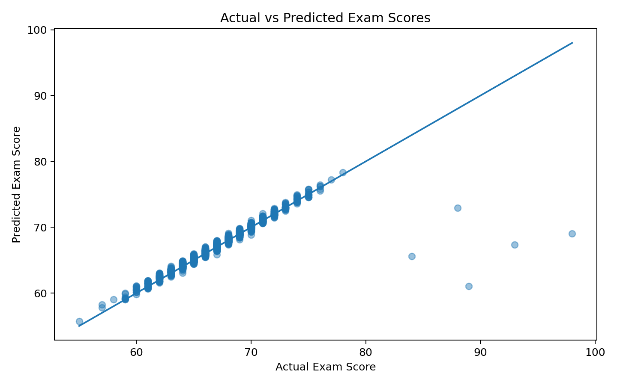
Figure 6. Actual vs Predicted Exam Scores
The actual-versus-predicted plot shows how closely the selected regression model's predictions follow the observed test scores. Points closer to the diagonal reference line indicate smaller prediction errors.

